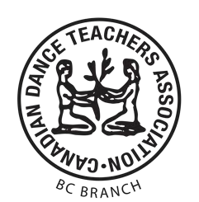**CANADIAN DANCE TEACHERS ASSOCIATION BC BRANCH**

**L’ASSOCIATION CANADIENNE DES PROFESSEURS DE DANSE SECTION BC**

# Registration

**Argentine Tango Salon Program**

**\* Required fields**

Candidate first and last name * _______________________________________________

CDTA-accredited program teacher: _____________________________________________

**Registering for \***

* Social Dance Workshop - $20.   
  Dancing for Dessert, Langley. Workshop date: ___________________________
* Program Enrollment - $60.   
  Social Dance Workshop required. Check if already attended:
* Program Challenge - $90.   
  Social Dance Workshop required. Check if already attended:



**Registering as \***  Leader Follower Both or not sure yet

|  |  |
| --- | --- |
|  |  |
| **Contact information** |  |
| Email address* | Telephone number |

 _____________________________________ _____________________________________

I consent to be contacted by email. I consent to be contacted by phone.

City and province of residence * _________________________________

**Questions and comments** ____________________________________________________________________

____________________________________________________________________